**DAILY ONLINE ACTIVITIES SUMMARY**

|  |  |  |  |  |  |  |  |  |
| --- | --- | --- | --- | --- | --- | --- | --- | --- |
| **Date:** | **28-05-2020** | | | | | **Name:** | **Dhanush Shetty** | |
| **Sem & Sec** | **8 A** | | | | | **USN:** | **4AL16CS032** | |
| **Online Test Summary** | | | | | | | | |
| **Subject** | | **SMS** | | | | | | |
| **Max. Marks** | | **60** | | **Score** | | | **57** | |
| **Certification Course Summary** | | | | | | | | |
| **Course** | **Authentication and Authorization of AWS** | | | | | | | |
| **Certificate Provider** | | | **AWS** | | **Duration** | | | **15 mins** |
| **Coding Challenges** | | | | | | | | |
| **Problem Statement:**   1. **Find last remaining element after reducing the Array.** | | | | | | | | |
| **Status: Solved** | | | | | | | | |
| **Uploaded the report in Github** | | | | | **Yes** | | | |
| **If yes Repository name** | | | | | **Dhanushshett/online_c_coding_repository** | | | |
| **Uploaded the report in slack** | | | | | **Yes** | | | |

Online Test Details: (Attach the snapshot and briefly write the report for the same)

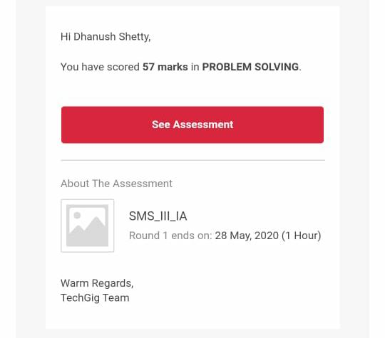

Certification Course Details: (Attach the snapshot and briefly write the report for the same)

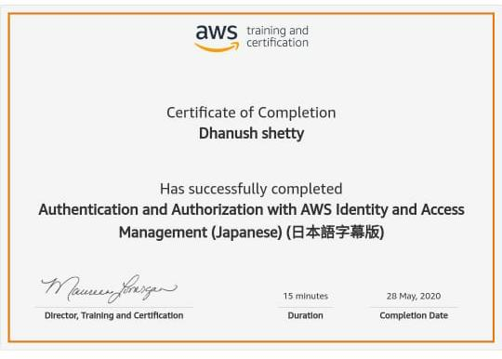

Coding Challenges Details: (Attach the snapshot and briefly write the report for the same)

**PROGRAM 1 .**

**// Write a C++ program to find last remaining element after reducing the Array.**

**#include<stdio.h>**

**void main()**

**{**

**int n,copy=152,remainder,sum,x;**

**printf("Enter a number\n");**

**scanf("%d",&n);**

**//starting copy from 152 as we know 153 is an armstron no**

**printf("Armstrong numbers are\n");**

**while(n!=0)**

**{**

**copy++;**

**x=copy;**

**sum=0;**

**//printf("\n2nd copy = %d ",copy);**

**while(copy!=0)**

**{**

**remainder=copy%10;**

**sum=sum+remainder*remainder*remainder;**

**copy=copy/10;**

**}**

**if(sum==x)**

**{**

**printf("\n%d",x);**

**n--;**

**}**

**copy=x;**

**}**

**}**